BAMIKA ENGINEERING CO. LTD
  - Code of Ethical Conduct in Business for Bidders and Providers
(Under Section 93 (2) of the PPDA Act, 2003)

- Ethical Principles
Bidders and providers shall at all times:-
- Maintain integrity and independence in their professional judgment and conduct;
- Comply with both the letter and the spirit of-
- The laws of Uganda; and
- Any executed contract.
- Avoid Associations with business and organizations, which conflict with this code.

- Standards
Bidders and providers shall –
- Strive to provide works, services and supplies of high quality and accept full responsibility for all works, services or supplies provided;
- Comply with the professional standards of their industry or of any professional body of which they are members.

- Conflict of Interest
Bidders and providers shall not accept contracts which would constitute a conflict of interest with, any prior or current contract with any PDE. Bidders and providers shall disclose to all concerned parties those conflicts of interest that cannot reasonably be avoided or escaped.

- Confidentiality and Accuracy of Information
- Information given by bidders and providers in the course of procurement processes or the performance of contracts shall be true, fair and not designed to mislead.
Providers shall respect the confidentiality of information received in the course of performance of a contract and shall not use such information for personal gain.

- Gifts and Hospitality
Bidders and providers shall not offer gifts or hospitality directly or indirectly, to the staff of a PDE that might be viewed by others as influencing a procurement decision of the Entity.

- Inducements
- Bidders and providers shall not offer or give anything of value to influence the action of a public official in the procurement process or contract execution.
- Bidders and providers shall not ask a public official to do anything inconsistent with the Act, Regulations, Guidelines or the Code of Ethical Conduct in Business.

- Fraudulent Practices
Bidders and providers shall not-
- Collude with other businesses and organization to deprive a PDE of the benefits of free and open competition;
- Enter into business arrangements that might prevent the effective operation of fair competition.
- Engage in deceptive financial practices, such as bribery, double billing or other improper financial practices.

- Misrepresent facts to influence a procurement process or the execution of a contract to the detriment of the PDE, or utter false documents;
- Unlawfully obtain information relating to a procurement process to influence the process or execution of a contract to the detriment of the PDE;
- Withholding information from the PDE during execution to the detriment of the PDE.

I ………………………….agree to comply with the above code of ethical conduct in business

________________ BAMIKA ENGINEERING CO. LTD
AUTHORISED SIGNATORY NAME OF BIDDER

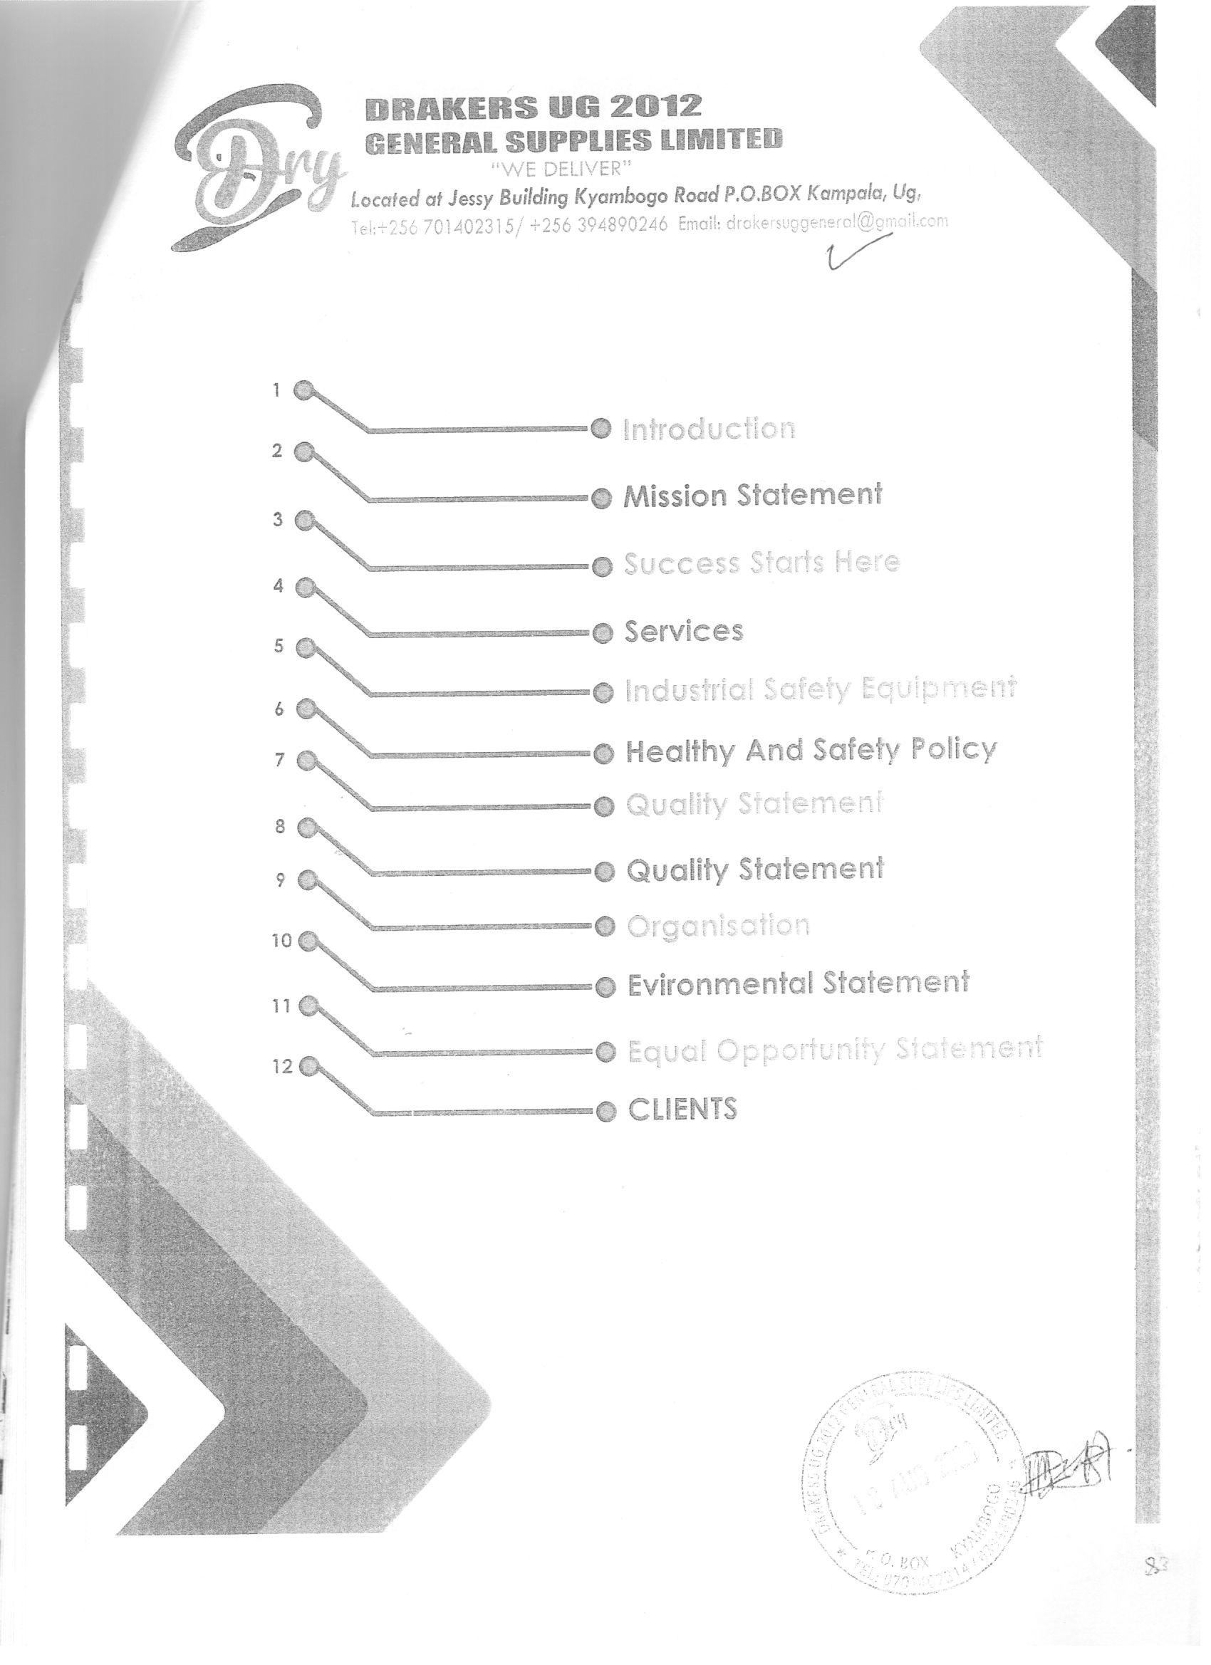
COMPANY PROFILE

BAMIKA ENGINEERING CO. LTD

INTRODUCTION
Established in 2019 in Uganda, BAMIKA ENGINEERING CO. LTD has over 4 years’ experience in delivering high quality services to enable clients to meet the growth challenges of quality and safety.
We as a company can reduce risk and improve compliance our accreditations offer customers peace of mind.
Our continued business is built on reputation and reliability, whilst meeting and exceeding our client’s expectations.
With our employees having knowledge of regulations, great technical ability and experience of working in a wide range of industries, we can minimize your costs and fulfill your requirements.

Contact us;

MISSION STATEMENT
Our Vision
Our vision is to focus on environmental activities to benefit society.
We are committed to achieving business and financial success while leaving a positive imprint on society.

Our Mission
Our mission is to be the Uganda’s leading contracting company focused on customer satisfaction. We seek to produce increased financial rewards and provide opportunities for growth and enrichment to employees, striving for honesty, reliability and integrity within the company.

Our values
Our values guide the way we work with our business partners, within our communities and with each other. Through our values, we have created a company where ideas can blossom, people can thrive and success can flourish.

Bamika Engineering Co. Ltd goes above and beyond to meet client’s expectations. We strive to provide services to our customers with emphasis on continuous improvement, pro-active approach, courtesy, timely response, and accuracy; with a goal of achieving total customer satisfaction.
SUCCESS STARTS HERE
INTEGRITY
- We act with integrity and show respect.
- Demonstrate a commitment to integrity and ethics.
- Show respect for and value all individuals for their diverse backgrounds, experiences, styles, approaches and ideas.
- Listen to others for understanding.
- Assume positive intent

ACCOUNTABILITY
- We are all accountable.
- Keep promises and commitments made to others.
- Take personal accountability for our actions and results.
- Focus on finding solutions and achieving results.
- Actively engage in discussions and commit to decisions once they are made.
- Involve others in decisions and plans that affect them.
- Personally, commit to the success and well-being of teammates.
- Embrace the belief that all injuries are preventable and that achieving a healthy and safe environment starts with “me.”

PASSION
- We are passionate about our business.
- Show pride in our company
- Delight our consumers and serve our customers through the high quality of our products and services.
- Promote a positive, energizing, optimistic and fun environment.
- Promote and implement creative and innovative ideas and solutions.
- Value, promote and fiercely protect our reputation.

HUMILITY
- We have the humility and hunger to learn.
- Value openness and curiosity to learn from anyone, anywhere.
- Seek and provide honest feedback.
- Be open to personal change and continuous improvement.
- Learn from mistakes and successes in equal measure.

- Never underestimate our competition.

SIMPLICITY
- We strive for simplicity.
- Seek to continually simplify and improve processes, procedures and activities.
- Work across organizational boundaries / levels and breakdown internal barriers.
- Deal with people and issues directly and openly.

RESULTS
- We love success.
- Achieve results and celebrate when we do.
- Help people to be their best by providing coaching and feedback.
- Work with others as a team to accomplish results and win.
- Have a “can do” (positive) attitude and drive to get the job done.
- Make people feel valued and appreciated.
- To make the tough calls

SERVICES
We are able to offer a complete range of services for all types of industrial and commercial projects. Our full range of services listed below:

Consumer electronics, communication equipment, computer software and consumables and optical products, General Construction Works, road works, Bridges and general Supplies.

THE SERVICES WE OFFER INCLUDE;
Supply, installation and maintenance of photocopiers, printers, switches, routers, UPS, automatic voltage regulators, servers and other peripherals.

Computers, Computer software, communication equipments, accessories and optical products supply installation and maintenance of CCTV cameras, air conditioners and ventilation systems.

Supply of stationary, office equipments consumables, educational and reading materials.

Supply and installation of solar equipments and generators

Supply of drugs, Laboratory, hospital equipment, pharmaceutical products and pharmaceutical preparation.

Supply of paper, paper products and packaging materials.

Supply of office, furniture and furnishings.

Supply of building and construction materials such as cement, iron sheets, paint, bricks, iron bars, sand among others…………………….

Supply of foods and beverages

Supply of agricultural tools
Supply, designing and Branding promotional items, Uniforms and corporate wear and Accolades. H 3D Digital printing on all kinds of surfaces Hiring of heavy –duty printers.

HEALTH & SAFTETY POLICY

It is the policy of Bamika Engineering Co. Ltd to comply with the Health and Safety at Work Act 1974 and subsequent legislation, and provide and maintain a healthy and safe working environment.
We aim to minimize the number of health & Safety and environmental incidents and ultimately to achieve an incident-free working environment.
We recognize and accept our duty to protect the health and safety of all visitors to the company, including sub-contractors and temporary workers, as well as any members of the public who might be affected by our operations.
Our health, safety and environmental policy will be continually monitored and updated to ensure continual improvement of the management systems.
The policy will be updated at least every 12 months.

QUALITY STATEMENT
Bamika Engineering Co. Ltd objective and mission is to offer its customers the highest quality of electrical and customer services. We strive to meet the highest-level customer satisfaction.

Bamika Engineering Co. Ltd focuses on personalized services by offering convenience and competitive costing to customers. Additionally, we have a wide scope of supply installation and maintenance skills. Bamika Engineering Co. Ltd main factor of work is testing work, however, when undertaking supply, we have a good range of suppliers who are able to deliver parts rapidly to decrease the waiting time for clients and ensures all deadlines are met.

Bamika Engineering Co. Ltd are committed to providing our customers, suppliers and employees with the highest quality of service and professionalism.

Bamika Engineering Co. Ltd are committed to the timely completion of all our services ensuring we meet your requirements on time and within the specified budget.

Where quality lapses arise Bamika Engineering Co. Ltd will provide suitable corrective and preventive measures. Bamika Engineering C. Ltd team strive to

meet and surpass your expectations Bamika Engineering Co. Ltd General supplies limited are committed to meet the requirements of ISO 9001 2008 and continually improve the effectiveness of this Quality Management System. This policy will be communicated to all employees so it is understood within the organization. This Quality Statement is reviewed on a regular basis for continual suitability. There are no exclusions within this policy.

Bamiika Engineering Co. Ltd take pride in the professional quality of our work and high level of service we provide to our clients, ensuring that their needs are clearly understood, defined and met throughout the project. We are committed to achieving and maintaining high standard of quality in all aspects of our business and to continually satisfy the expectations of our customers.

Organizational structure

BOARD OF DIRECTORS

GENERAL MANAGER

MANAGER TECHNICAL SERVICES
MANAGER FINANCE, CORPORTATION SERVICES
SENIOR OFFICERS
ADMIN OFFICER
PROCUREMENT OFFICER
SENIOR ACCOUNTANT
IT SPECIALIST
SECRETARY
GENERAL WORKERS

At Bamika Engineering Co. Ltd, we strive for excellence in all areas of operation and we are committed to working with you to make your systems always available, responsive and in good condition. As a result we are known in the market place to build a reputation locally for the provision of quality products

and services. Opportunities are still ahead of us though, and we do not intend to rest on our laurels.

Bamika Engineering Co. Ltd has successfully executed a number of projects and we are increasingly expanding our clientele. The success of Bamika Engineering General supplies limited lies not only in successfully completing the projects on time, but in understanding the client’s requirements effectively and executing them.
Working for these clients has enabled us meet and do various kinds of businesses which has exposed to different scenarios of possible network failures and other technical products and challenges. We therefore believe that we have enough required experience and expertise to offer you technology transformations and make your business reach its goals.

ENVIRONMENTAL STATEMENT
Bamika Engineering Co. Ltd are continuously working to improve environmental impact through energy and cost saving programs and products, as well as carrying out assessments and advice.
As a business Bamika Engineering Co. Ltd are committed to reducing environmental impact by:
To ensuring that our activities are safe for our employees.
To maintaining an environmental management system with due reference to the standard BS EN ISO 14001:2004
To Complying with or exceeding current legal requirements.
To Demonstrating a commitment to the prevention of pollution from processes utilized by our business.
To whenever possible reducing the environmental impact of goods and services supplied by the Company.
To minimizing the waste produced in all parts of our business.
To seeking to integrate environmental considerations to future business policy decisions.
To communicating this policy as appropriate to customers and suppliers. U demonstrate continuous improvement and development of our environmental management system.
To Developing systems to implement and review this policy.

EQUAL OPPORTUNITY STATEMENT
Bamika Engineering Co. Limited equal opportunities policy is to strive to ensure that no resident, tenant, day attendee, volunteer, staff member of applicant receives less favorable treatment in employment or the provision of services on the grounds of physical or mental disability, sex, gender reassignment, race, colour, nationality, ethnic origin, marital status, sexual orientation, age or religion.
The context of this equal opportunities policy lies within our principles of:
Bamika Engineering Co. Limited aims to be an inclusive organization where everyone is treated with respect and dignity, and where there is equal opportunity for all.
Bamika Engineering Co. Ltd respects and values the diversity of its entire work force.
This means that all Bamika Engineering Co. Ltd staff should understand and respect that there is a diverse work force and user community and that everyone has the right to be treated with dignity and equality. This includes the legal and ethical requirement for Bamika Engineering Co. Ltd to provide electrical services and conditions of employment that are appropriate to the needs of a diverse society.
Bamika Engineering Co. Ltd will tackle barriers to participation and create a culture in which equal opportunities and equal treatment are priority for all staff and users. In the recruitment, training, pay and management of staff, and in all our day–today work with both colleagues and users, we seek to create an environment where attitudes and biases that hinder the progress of individuals and groups are dismantled and where we work together in mutual respect and tolerance.
This policy forms the basis of all interactions within, Bamika Engineering Co. Ltd including recruitment, staff development and service delivery.
Bamika Engineering Co. Ltd is an equal opportunities employer and is committed to developing, maintaining and supporting a policy of equal opportunities in employment. This policy meets the statutory requirements of:

Equal Pay Acts (1970 & 1983)
Health and Safety at Work Act (1974)
Sex Discrimination Act (1975 & 1986)
Employment Equality (Sexual Orientation) Regulations 2003
Race Relations Act (1976) (Amended 2003)
Employment Equality (Religion or Belief) Regulations 2003

Disability Discrimination Act (1995 & 2005)
Public Interest Disclosures Act (Whistle blowing Act) (1998)
Employee Relations Act 1999
Disability Rights Commission Code of Practice
Civil Partnership Act (2004)
And other relevant domestic and European Law.

